Assignment 1: Snowflake Environment Setup (Beginner)
Objective: Understand Snowflake UI and basic objects.
Tasks
- Log in to Snowflake (trial account).
- Create:
  - A Database
  - A Schema
  - A Virtual Warehouse
- Show all databases and schemas.
- Suspend and resume the warehouse.
Deliverable:
- SQL script
- Screenshot of created objects
Create or replace Database Security_db;
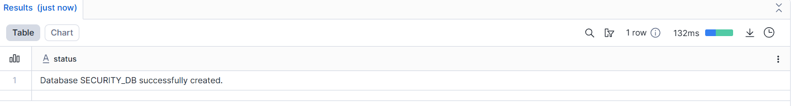
Create or replace Schema security_db.security;
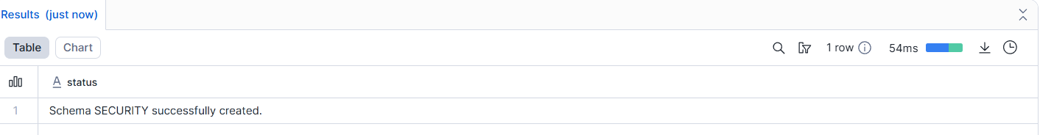
Create Virtual Warehouse:
CREATE or replace WAREHOUSE Security_wh
WITH
WAREHOUSE_SIZE = 'XSMALL'
AUTO_SUSPEND = 60
AUTO_RESUME = TRUE;
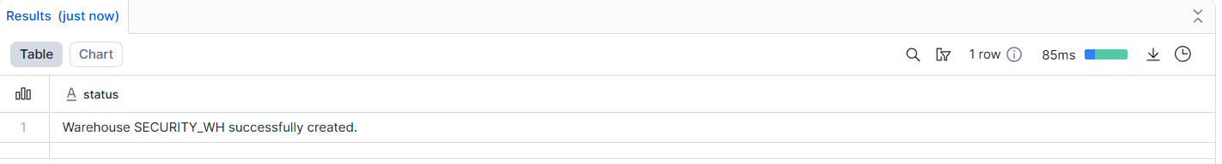
Showing All Databases:
show databases;
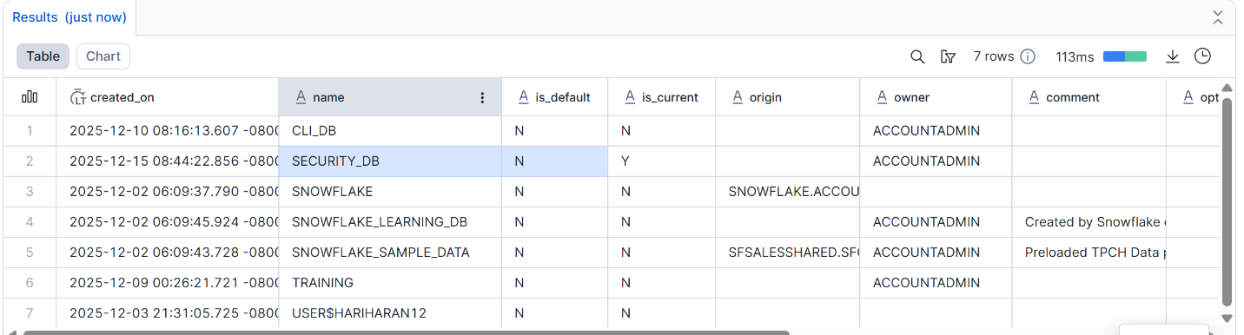
Showing All Schemas:
show schemas;
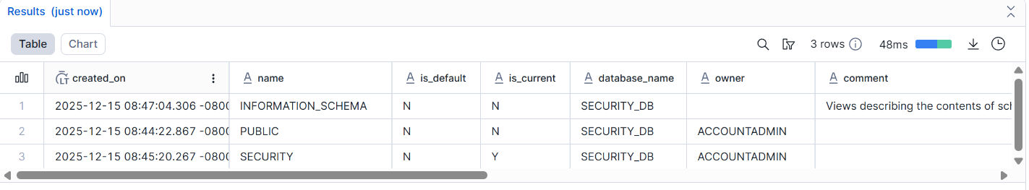
-- Why We SUSPEND and Resume,Because Suspend is a cost save, Resume is query run
-- Suspending a warehouse stops compute usage to save cost, and resuming it restarts the warehouse to run queries.
Suspend the warehouse:
ALTER WAREHOUSE security_wh SUSPEND;
Resume the warehouse:
ALTER WAREHOUSE security_wh RESUME;

Assignment 2: User, Role & Access Control (RBAC)
Objective: Learn Snowflake security and role hierarchy.
Tasks
- Create roles:
  - STUDENT_ROLE
  - INSTRUCTOR_ROLE
- Create users:
  - student1
  - instructor1
- Assign:
  - STUDENT_ROLE → student1
  - INSTRUCTOR_ROLE → instructor1
- Grant permissions:
  - Student → SELECT on tables
  - Instructor → SELECT, INSERT
- Verify access using SHOW GRANTS.
Deliverable:
- SQL commands
Create Student_role and instructor_role:

create role student_role;
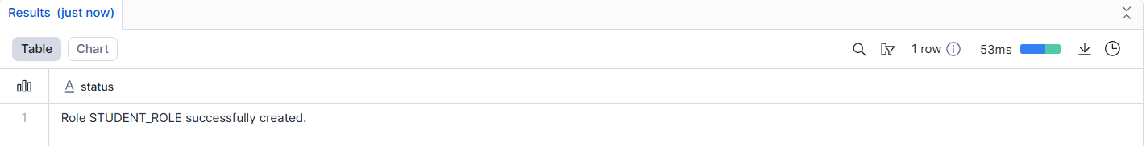
create role instructor_role;
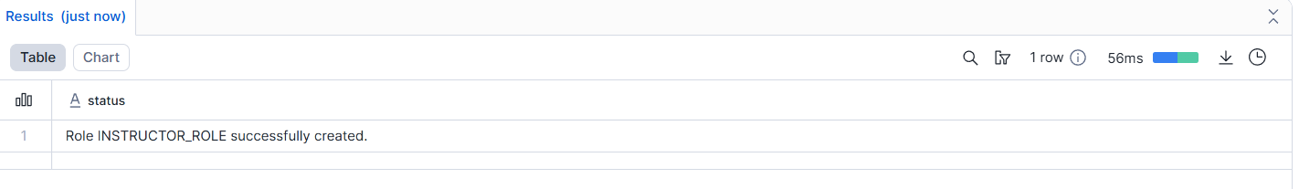
Create Users:
Create User student1
password='student123'
Must_change_password=True;

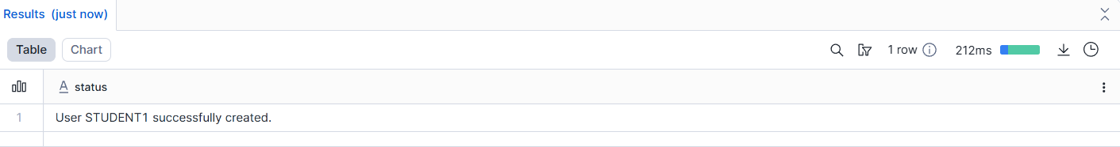
CREATE or replace user instructor1
password='INSTRUCTOR123'
must_change_password=True;

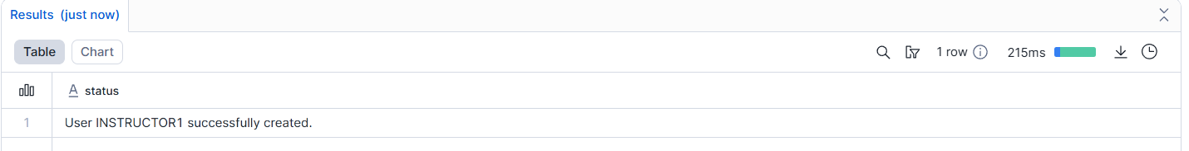
Assign the roles to Users:
GRANT role student_role to user student1;
GRANT role instructor_role to user instructor1;
Grant permissions:
-- Student role: SELECT only
GRANT SELECT
ON TABLE security_db.security.students
TO ROLE STUDENT_ROLE;

-- Instructor role: SELECT and INSERT
GRANT SELECT, INSERT
ON TABLE security_db.security.students
TO ROLE INSTRUCTOR_ROLE;

SHOW GRANTS TO USER student1;
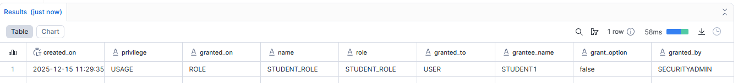
SHOW GRANTS TO USER instructor1;
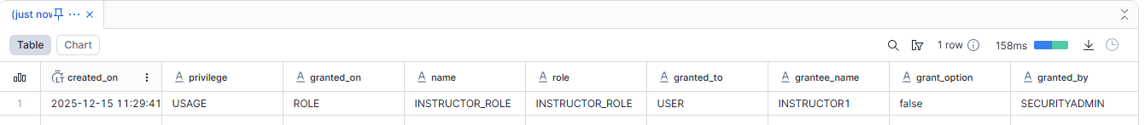
Short explanation of RBAC
- Access is given to roles, not directly to users.
- Users get permissions by assigning roles to them.
- It helps keep data secure and easy to manage.

Assignment 3: Table Creation & Data Loading
Objective: Work with structured data.
Tasks
- Create a table:
CREATE TABLE students (
id INT,
name STRING,
course STRING,
score INT
);
- Insert at least 10 records.
- Query:
  - All students
  - Students with score > 80
- Update one record.
- Delete one record.
Deliverable:
- SQL file with queries
- Output screenshots
Create a table:
CREATE TABLE security_db.security.students (
id INT,
name varchar(20),
course varchar(20),
score INT
);
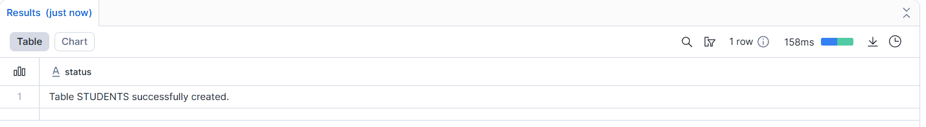

Insert at least 10 records:
INSERT INTO students (id, name, course, score) VALUES
(1, 'Arun', 'Data Engineering', 85),
(2, 'Priya', 'Data Science', 92),
(3, 'Karthik', 'Snowflake', 78),
(4, 'Divya', 'Python', 88),
(5, 'Ramesh', 'SQL', 90),
(6, 'Suresh', 'Data Engineering', 72),
(7, 'Meena', 'Snowflake', 95),
(8, 'Vijay', 'Python', 80),
(9, 'Anitha', 'Data Science', 84),
(10, 'Rahul', 'SQL', 76),
(11, 'Deepa', 'Snowflake', 89),
(12, 'Ganesh', 'Data Engineering', 91),
(13, 'Lakshmi', 'Python', 83),
(14, 'Manoj', 'SQL', 68),
(15, 'Kavya', 'Data Science', 87),
(16, 'Naveen', 'Snowflake', 93),
(17, 'Pooja', 'Python', 79),
(18, 'Sathish', 'Data Engineering', 82),
(19, 'Aishwarya', 'SQL', 88),
(20, 'Hari', 'Data Science', 90),
(21, 'Bala', 'Data Engineering', 55),
(22, 'Keerthi', 'Data Science', 48),
(23, 'Mohan', 'Snowflake', 52),
(24, 'Swathi', 'Python', 45),
(25, 'Prakash', 'SQL', 58),
(26, 'Renuka', 'Data Engineering', 49),
(27, 'Sanjay', 'Snowflake', 54),
(28, 'Nithya', 'Python', 50),
(29, 'Ajith', 'Data Science', 47),
(30, 'Revathi', 'SQL', 56),
(31, 'Aravind', 'Snowflake', 53),
(32, 'Kavitha', 'Data Engineering', 44),
(33, 'Kumar', 'Python', 59),
(34, 'Sneha', 'SQL', 46),
(35, 'Vinoth', 'Data Science', 51),
(36, 'Preethi', 'Snowflake', 42),
(37, 'Raghul', 'Python', 57),
(38, 'Malathi', 'Data Engineering', 48),
(39, 'Saravanan', 'SQL', 55),
(40, 'Nandhini', 'Data Science', 49);
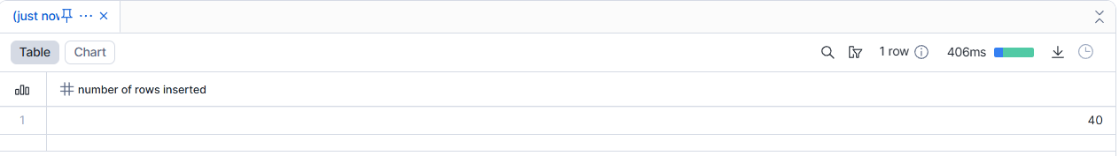

Show all Students:
select*from students;
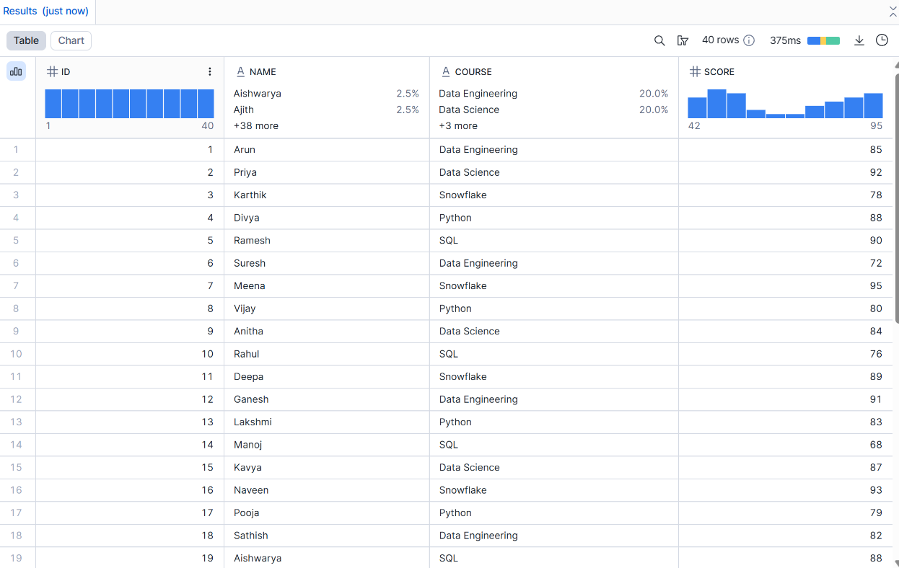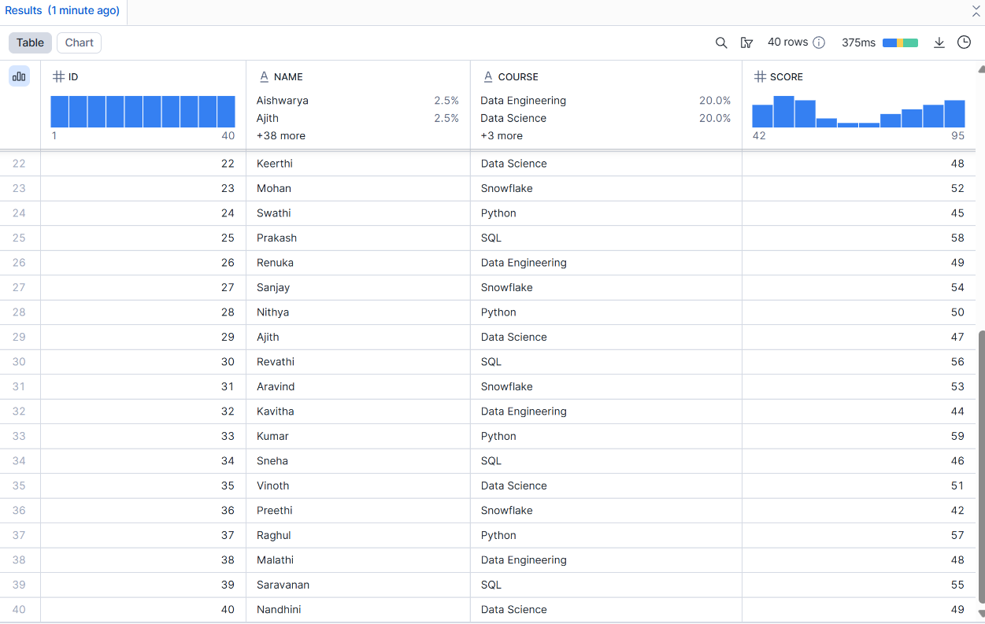

Query:
select *from students where score >80;
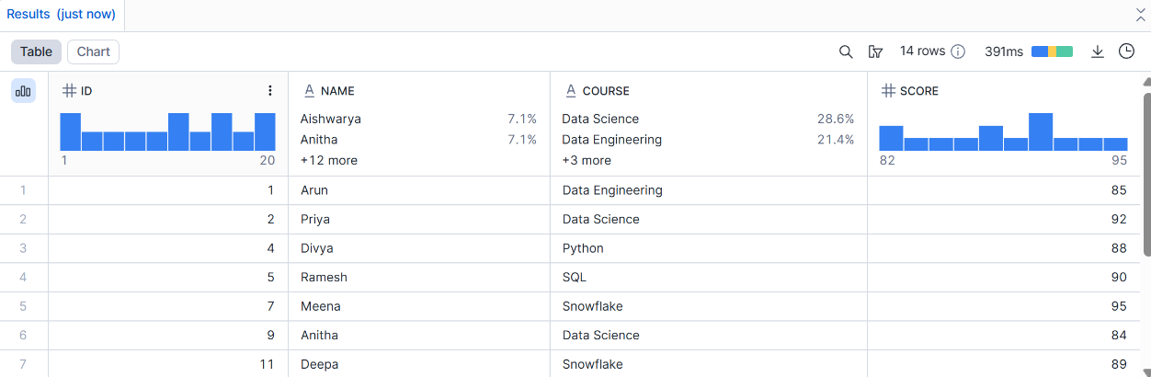
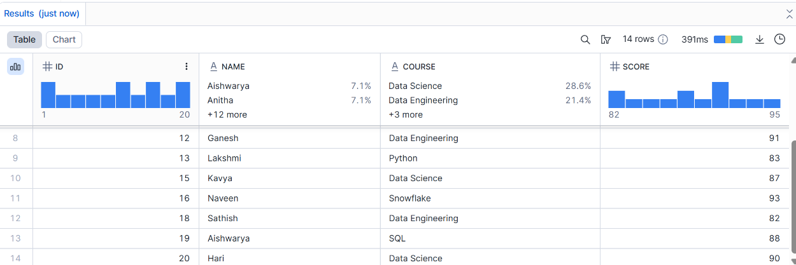
Update one record:
UPDATE students
SET name = 'Hari',course = 'Snowflake'
WHERE id = 1;
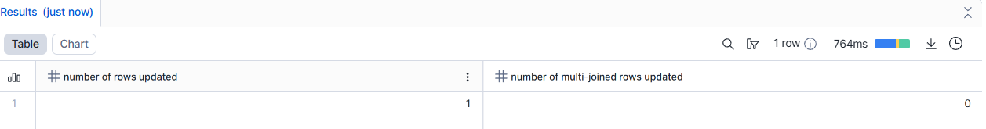
1st Record Name and course changed
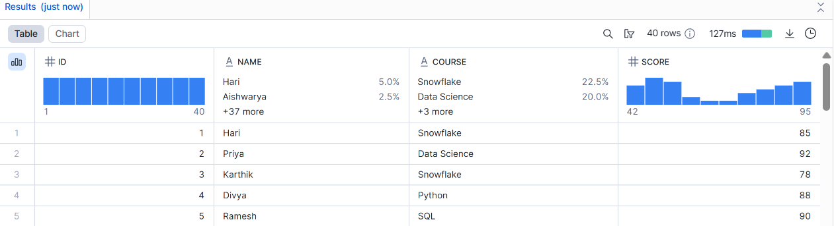

Delete the one record:
DELETE FROM students WHERE id = 2;

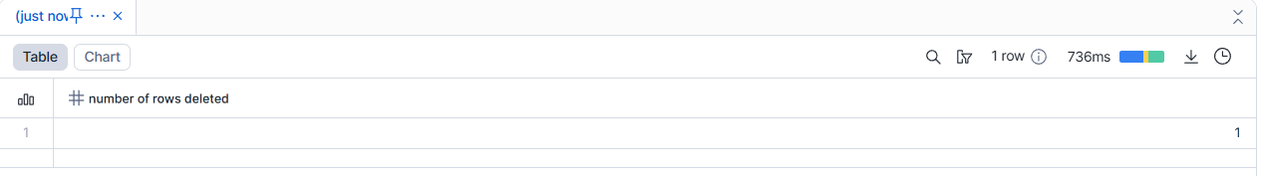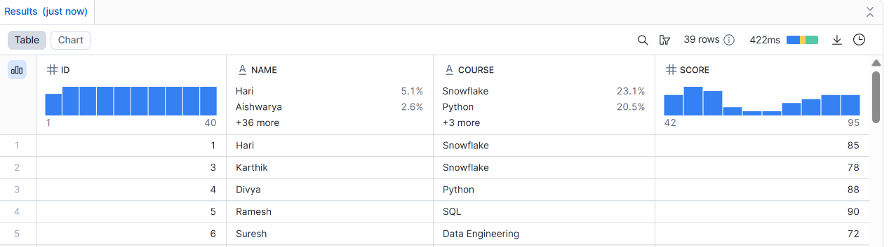

Assignment 4: File Loading using Stage & COPY (Intermediate)
Objective: Learn Snowflake data ingestion.
Tasks
- Create an internal stage.
- Upload a CSV file.
- Use COPY INTO to load data.
- Validate loaded records.
- Handle one data error using VALIDATION_MODE.
Deliverable:
- SQL script
- CSV file
- Query output
Create an internal stage:
Create Stage security_stg;
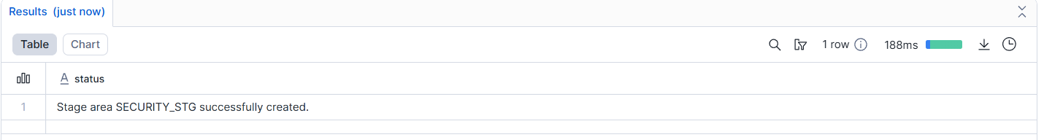
Upload a CSV file:
Upload using UI:
Go to Snowflake UI
Databases → Schema → Stages
Select stage → Upload file
Why we use UI:
Easy and visual
Good for learning, testing, demos
Small files
Upload using CMD / CLI (PUT command):
PUT file://C:/data/students.csv @security_stg;
Why we use:
Faster
Can upload large files
Can automate (scripts, jobs)
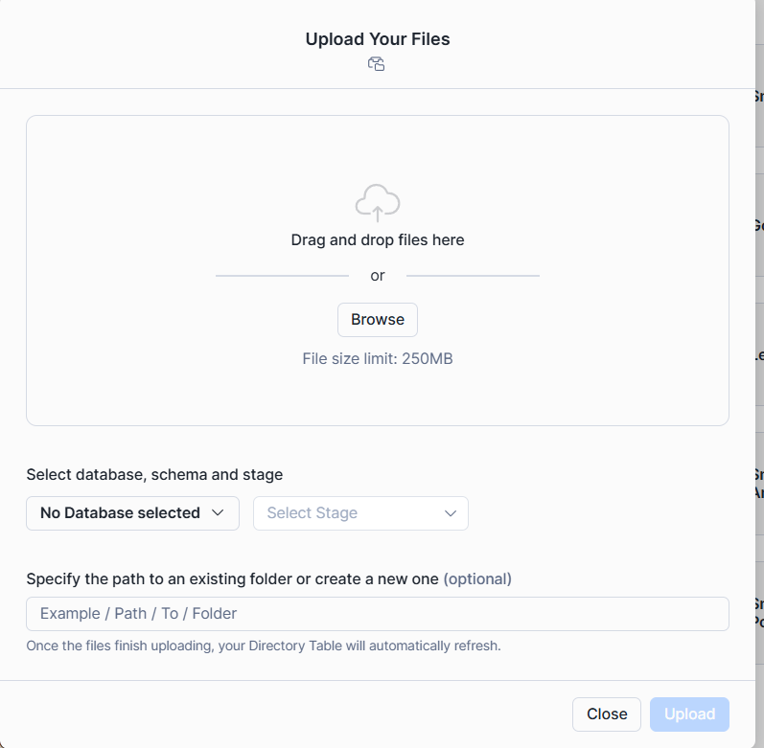
Use COPY INTO to load data:
COPY INTO students
FROM @security_stg/security.csv
FILE_FORMAT = (
TYPE = 'CSV'
SKIP_HEADER = 1
);
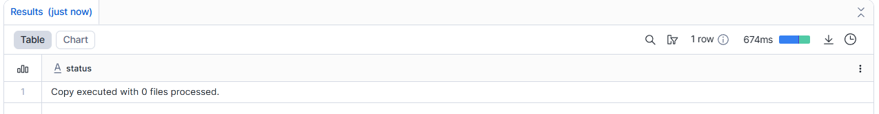
Validate loaded records:
checking records
SELECT COUNT(*) FROM students;
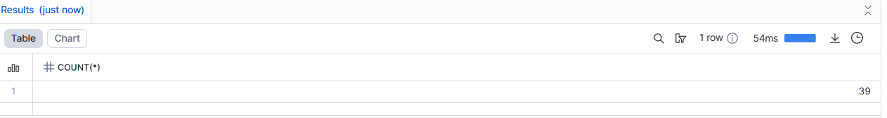
Handle one data error using VALIDATION_MODE:
COPY INTO students
FROM @security_stg/students_error.csv
FILE_FORMAT = (
TYPE = 'CSV'
SKIP_HEADER = 1
)
VALIDATION_MODE = 'RETURN_ERRORS';
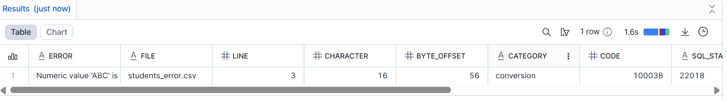

Assignment 5: Time Travel & Data Recovery
Objective: Understand Snowflake Time Travel.
Tasks
- Delete records from a table.
- Query data using Time Travel.
- Restore deleted data.
- Explain how Time Travel helps in recovery.
Deliverable:
- SQL queries
- Short explanation

Assignment 6: Warehouses & Performance
Objective: Learn compute management.
Tasks
- Create:
  - SMALL_WH
  - MEDIUM_WH
- Run same query on both warehouses.
- Compare execution time.
- Suspend unused warehouse.
Deliverable:
- Query history screenshot
Create SMALL warehouse:
CREATE or replace WAREHOUSE SMALL_WH
WITH
WAREHOUSE_SIZE = 'SMALL'
AUTO_SUSPEND = 60
AUTO_RESUME = TRUE;
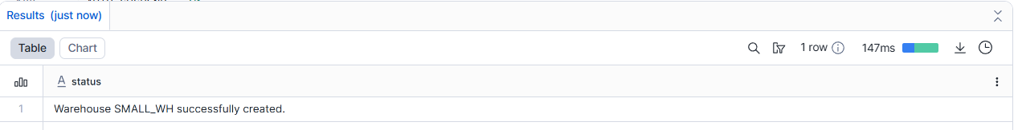
Create MEDIUM warehouse:
CREATE WAREHOUSE MEDIUM_WH
WITH
WAREHOUSE_SIZE = 'MEDIUM'
AUTO_SUSPEND = 60
AUTO_RESUME = TRUE;
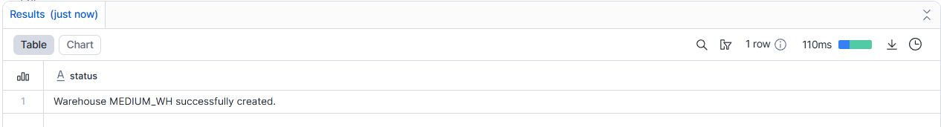
- Created a new table to store structured movie data.
- Uploaded a large CSV file from the local system to a Snowflake internal stage using the PUT command in CLI.
- Loaded the staged data into the table using the COPY INTO command.
- Verified the data load by querying the table and checking record count.
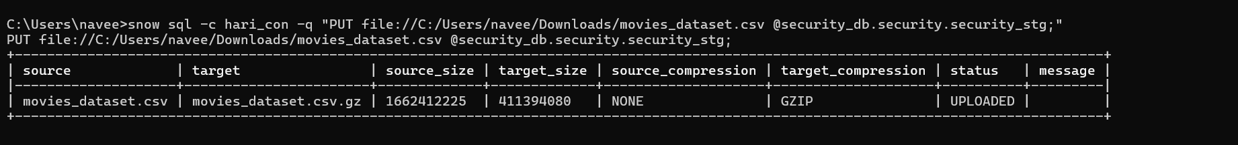

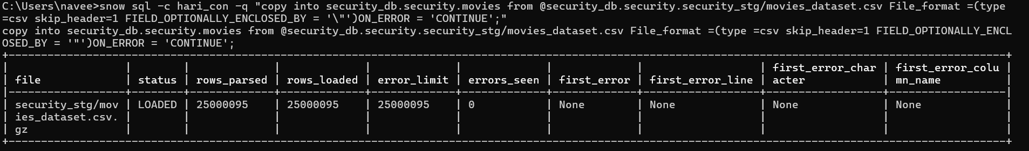

USE WAREHOUSE SMALL_WH;
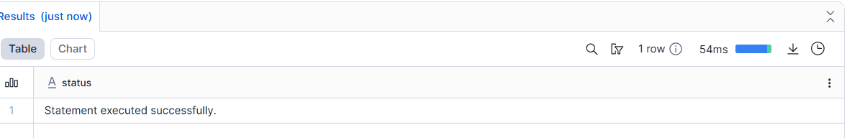
SELECT movie_name, genre,
DENSE RANK () OVER (PARTITION BY genre ORDER BY rating DESC) AS rating_movies
FROM movies;
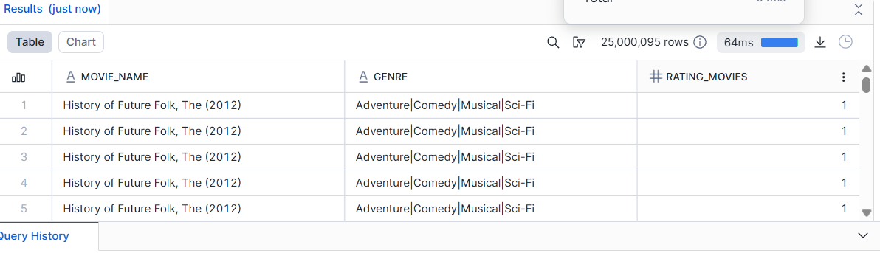
use warehouse medium_wh;
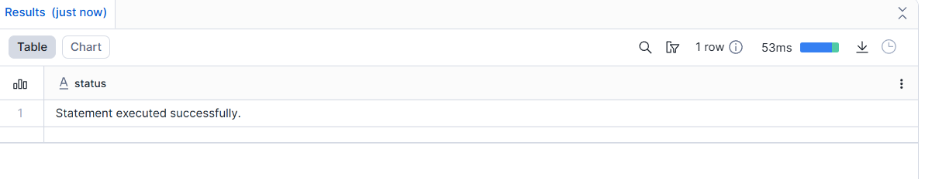
SELECT course, COUNT(*) AS total_students
FROM security_db.security.students
GROUP BY course;
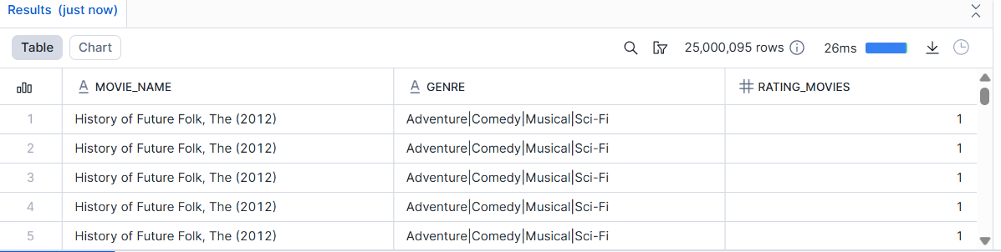
SMALL_WH → Loads slower, suitable for small files
MEDIUM_WH → Loads large files (like 500 MB) faster
Medium_wh:
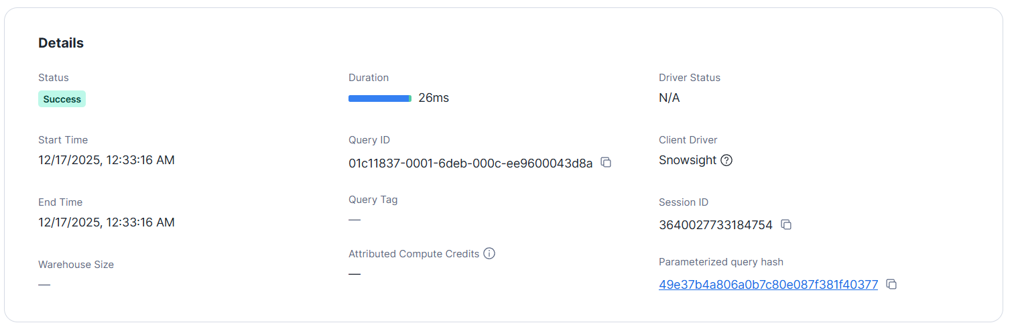
small_wh:
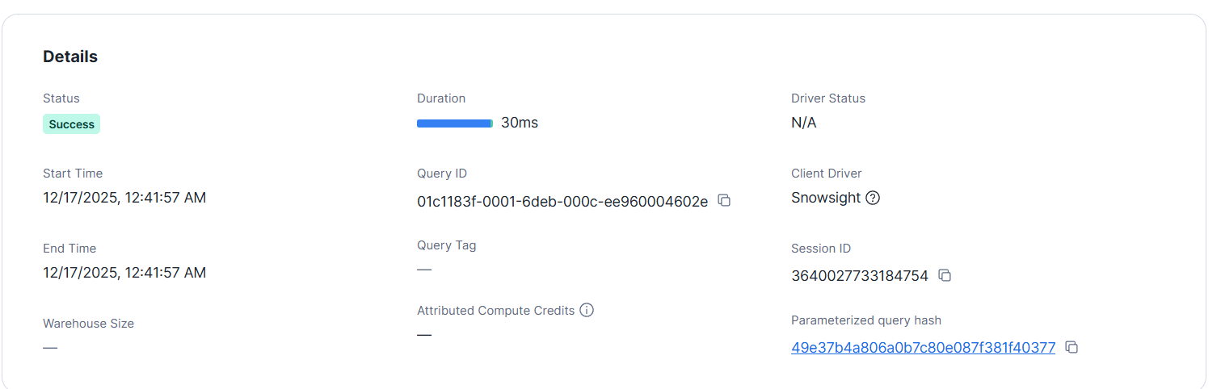
Performance comparison notes:
- The same query was executed on SMALL and MEDIUM warehouses.
- The MEDIUM warehouse completed the query faster due to higher compute resources.
- The SMALL warehouse took more execution time because of limited compute.
- Larger warehouses provide better performance for large data and heavy workloads.
- Suspending unused warehouses helps reduce compute cost.
Suspend unused warehouse:
ALTER WAREHOUSE SMALL_WH suspend;
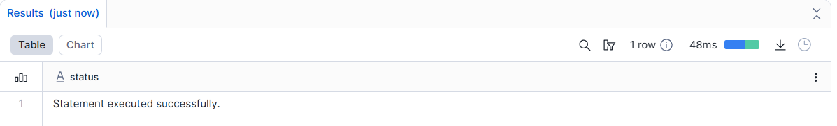
SHOW WAREHOUSES LIKE 'SMALL_WH';
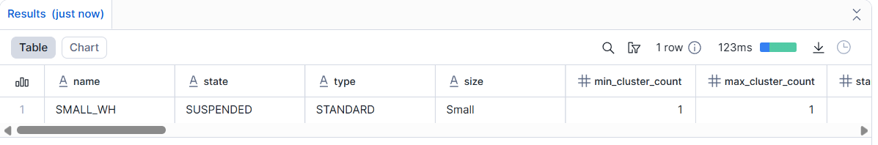

ALTER WAREHOUSE SMALL_WH resume;
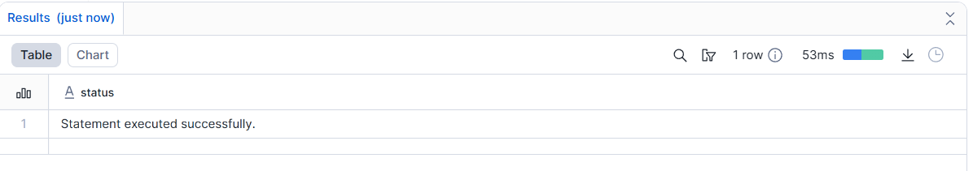

SHOW WAREHOUSES LIKE 'SMALL_WH';
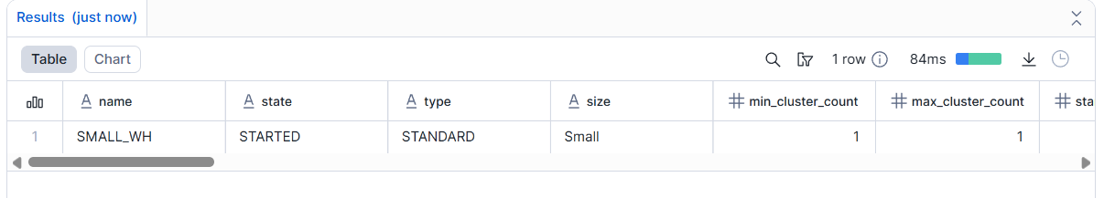

Assignment 7: Views & Secure Views
Objective: Control data visibility.
Tasks
- Create a View hiding sensitive columns.
- Create a Secure View.
- Grant view access to Student role.
- Test access using Student role.
Deliverable:
- SQL queries
- Explanation of Secure View

Create a View hiding sensitive columns:

CREATE OR REPLACE VIEW student_view AS
SELECT id,name,
course -- score column is hide
FROM security_db.security.students;
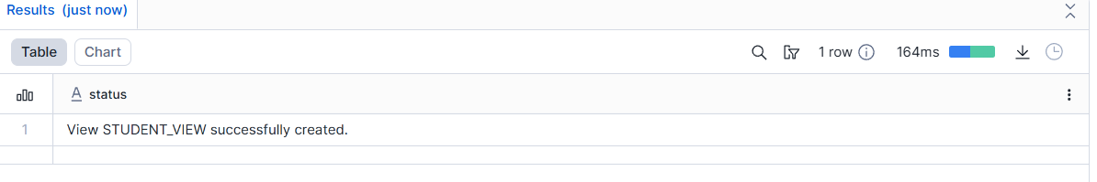Create a Secure View:

CREATE OR REPLACE SECURE VIEW student_secure_view AS
SELECt id, name,course
FROM security_db.security.students;
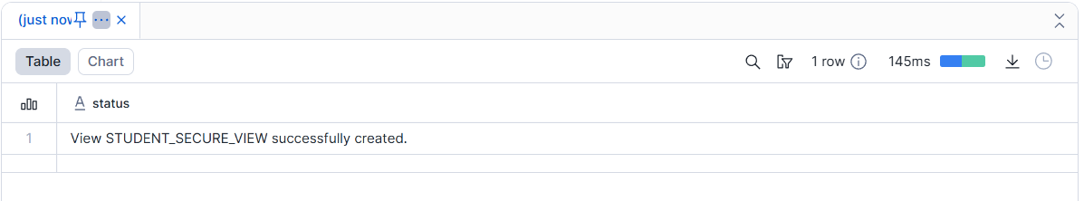
Grant view access to Student role:
GRANT SELECT
ON VIEW security_db.security.student_secure_view
TO ROLE STUDENT_ROLE;

Assignment 8: Scaling & Auto Suspend (Advanced)
Objective: Understand Snowflake scaling behavior.
Tasks
- Enable auto-suspend and auto-resume.
- Configure multi-cluster warehouse.
- Simulate concurrent queries.
- Observe scaling behavior.
Deliverable:
- Warehouse configuration
- Query history evidence

Enable auto-suspend and auto-resume:

ALTER WAREHOUSE SMALL_WH
SET
AUTO_SUSPEND = 60,
AUTO_RESUME = TRUE;

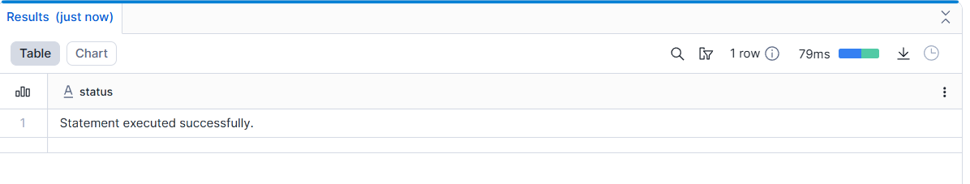

ALTER WAREHOUSE MEDIUM_WH
SET
AUTO_SUSPEND = 60,
AUTO_RESUME = TRUE;

Configure multi-cluster warehouse:
Multi-cluster warehouses automatically scale compute resources to handle concurrent queries efficiently without manual intervention.
CREATE OR REPLACE WAREHOUSE MC_WH
WITH
WAREHOUSE_SIZE = 'MEDIUM'
WAREHOUSE_TYPE = 'STANDARD'
MIN_CLUSTER_COUNT = 1
MAX_CLUSTER_COUNT = 3
SCALING_POLICY = 'STANDARD'
AUTO_SUSPEND = 60
AUTO_RESUME = TRUE;
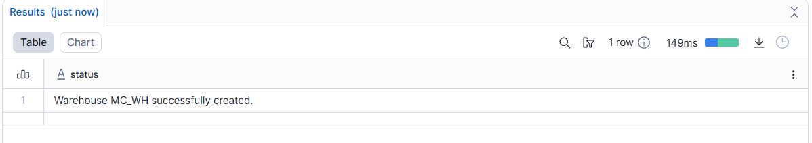

Simulate concurrent queries:
Concurrent queries were simulated by running multiple queries at the same time using different worksheets.
USE WAREHOUSE MC_WH;

SELECT COUNT(*) FROM security_db.security.students;
SELECT COUNT(*) FROM SNOWFLAKE_SAMPLE_DATA.TPCH_SF100.ORDERS;

SELECT COUNT(*) FROM SNOWFLAKE_SAMPLE_DATA.TPCH_SF100.CUSTOMER

Observe scaling behaviour:
CREATE OR REPLACE WAREHOUSE MC_WH
WITH
WAREHOUSE_SIZE = 'MEDIUM'
WAREHOUSE_TYPE = 'STANDARD'
MIN_CLUSTER_COUNT = 1
MAX_CLUSTER_COUNT = 3
SCALING_POLICY = 'STANDARD'
AUTO_SUSPEND = 60
AUTO_RESUME = TRUE;





